Parabolic SAR indicator is represented by the yellow dots……. So each time the SAR price shows a change in the direction of the trend it matches the Sidus method.

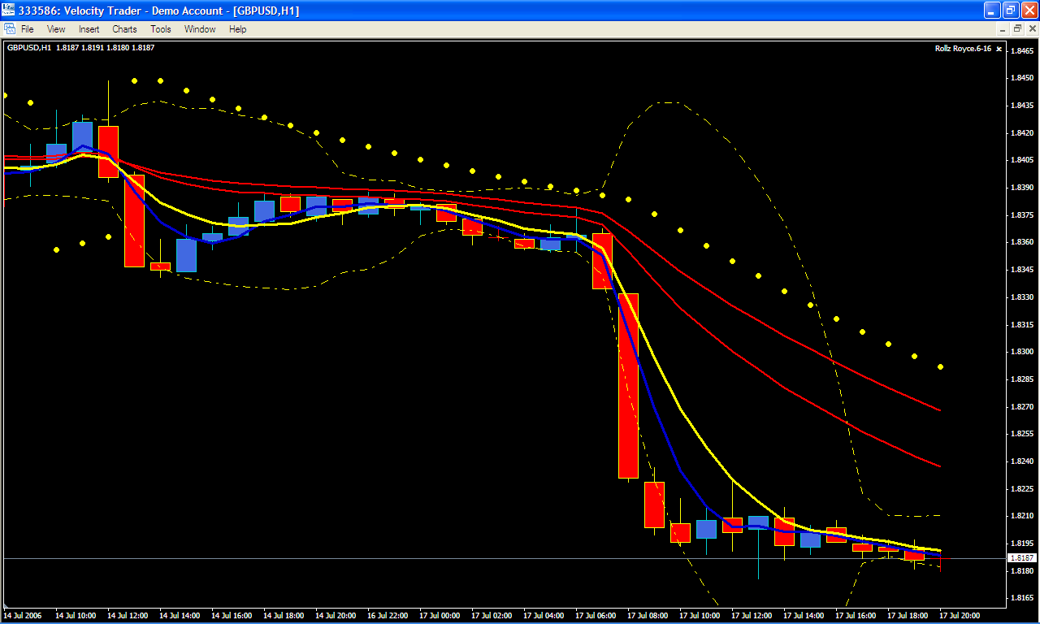

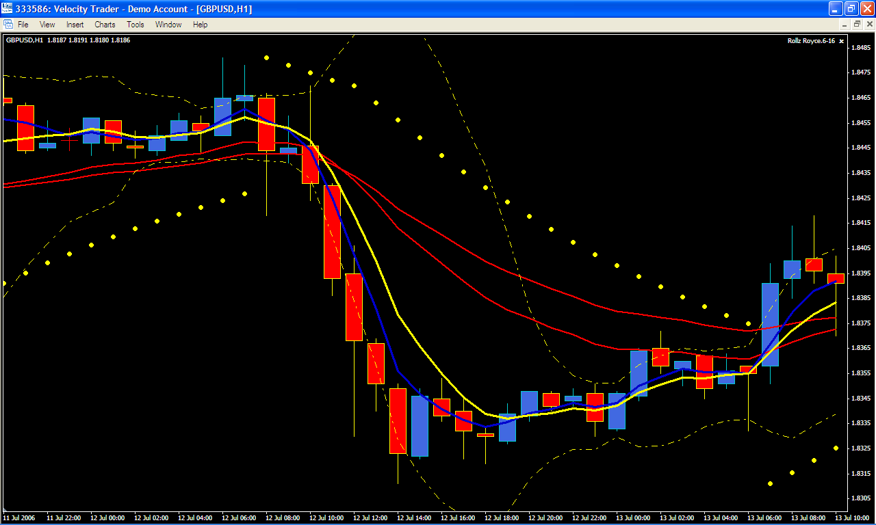

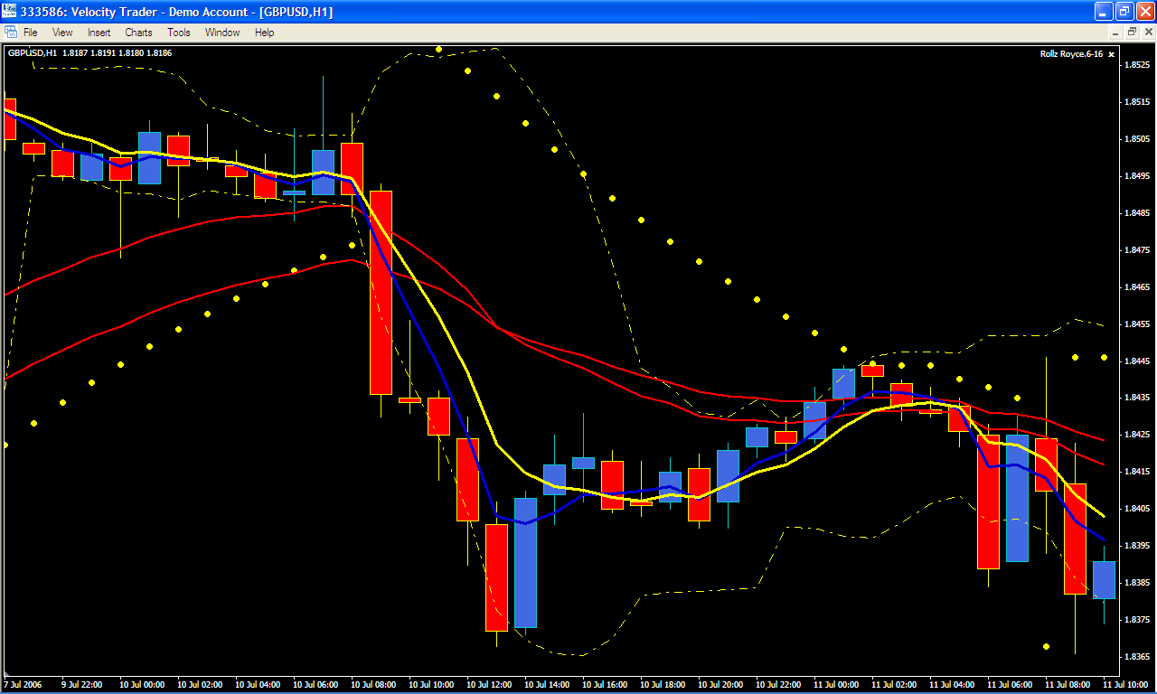

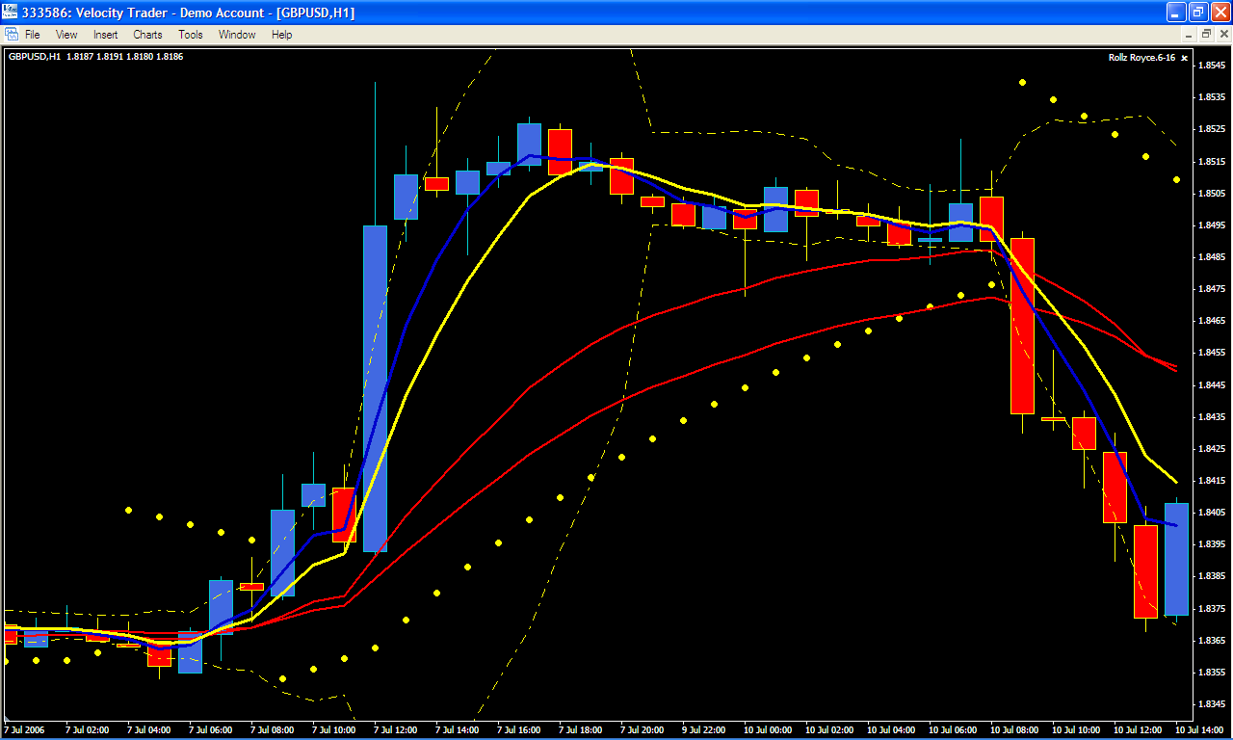

Below is a 260+ pip run! SAR picked it just as the Sidus method did….

